

Service Note

We recommend top links are removed and inspected before every race for cracks.

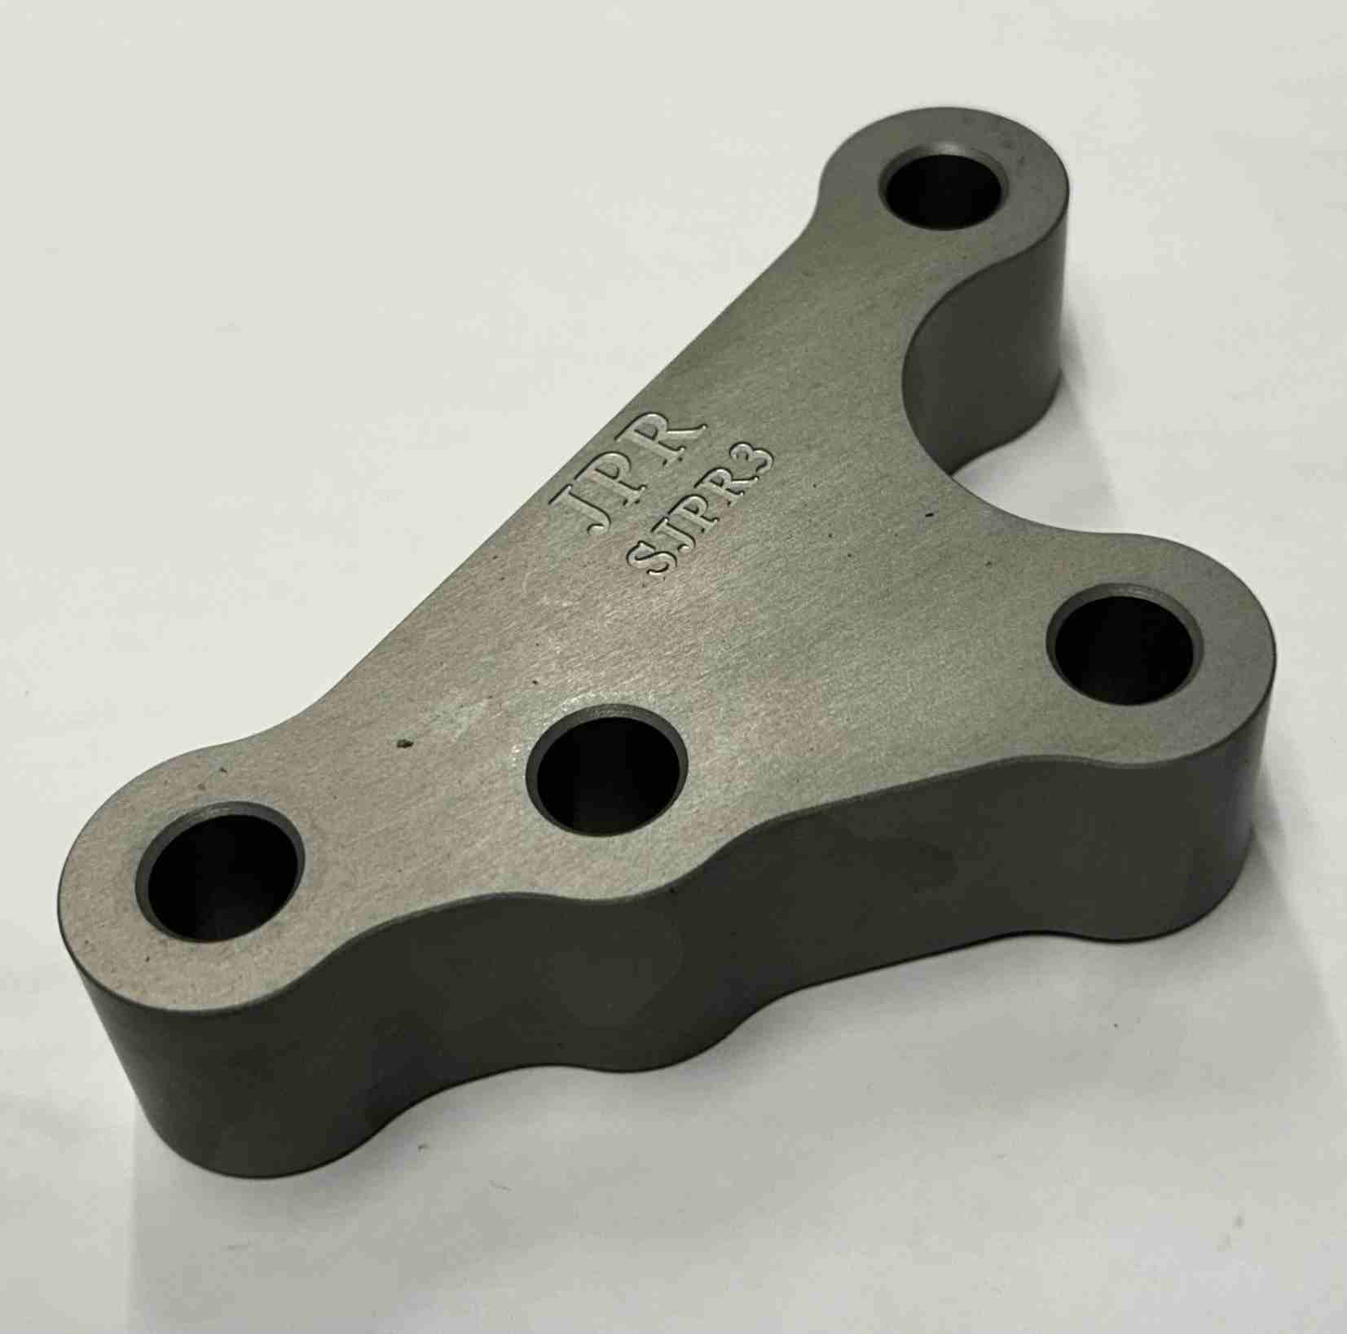

Issue date 14th April 2026

