

Service Note

We recommend using a M5 nut on the back of your alternator to stop the securing bolt coming loose.

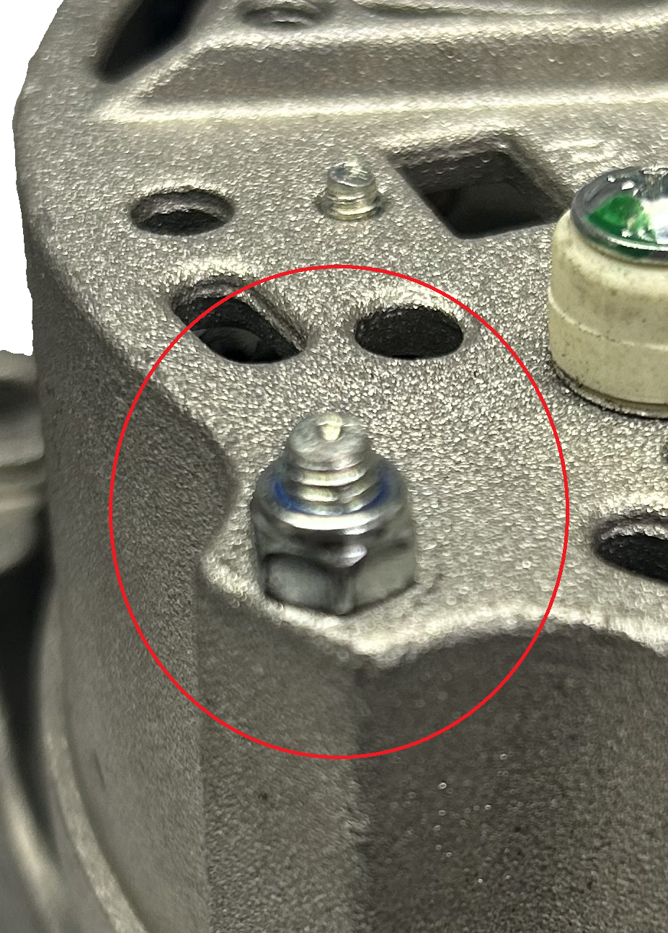

Issue date 14th April 2026.

